OpenCare
Hospital Operations Intelligence & Decision Platform
Bed Pressure Intelligence · Product Concept Document · Demo Release

This document has been prepared to explain the logic, architecture, and operational value of the OpenCare platform, with specific focus on the Bed Pressure Intelligence use case. It is intended for healthcare operations leaders, digital transformation teams, product investors, and clinical informatics reviewers.
The product described here is a proof-of-concept demo. All metrics, predictions, and decision examples are illustrative. This document assesses the demo as a demo — with clarity about what is already strong, what the direction is, and what production maturation would involve.

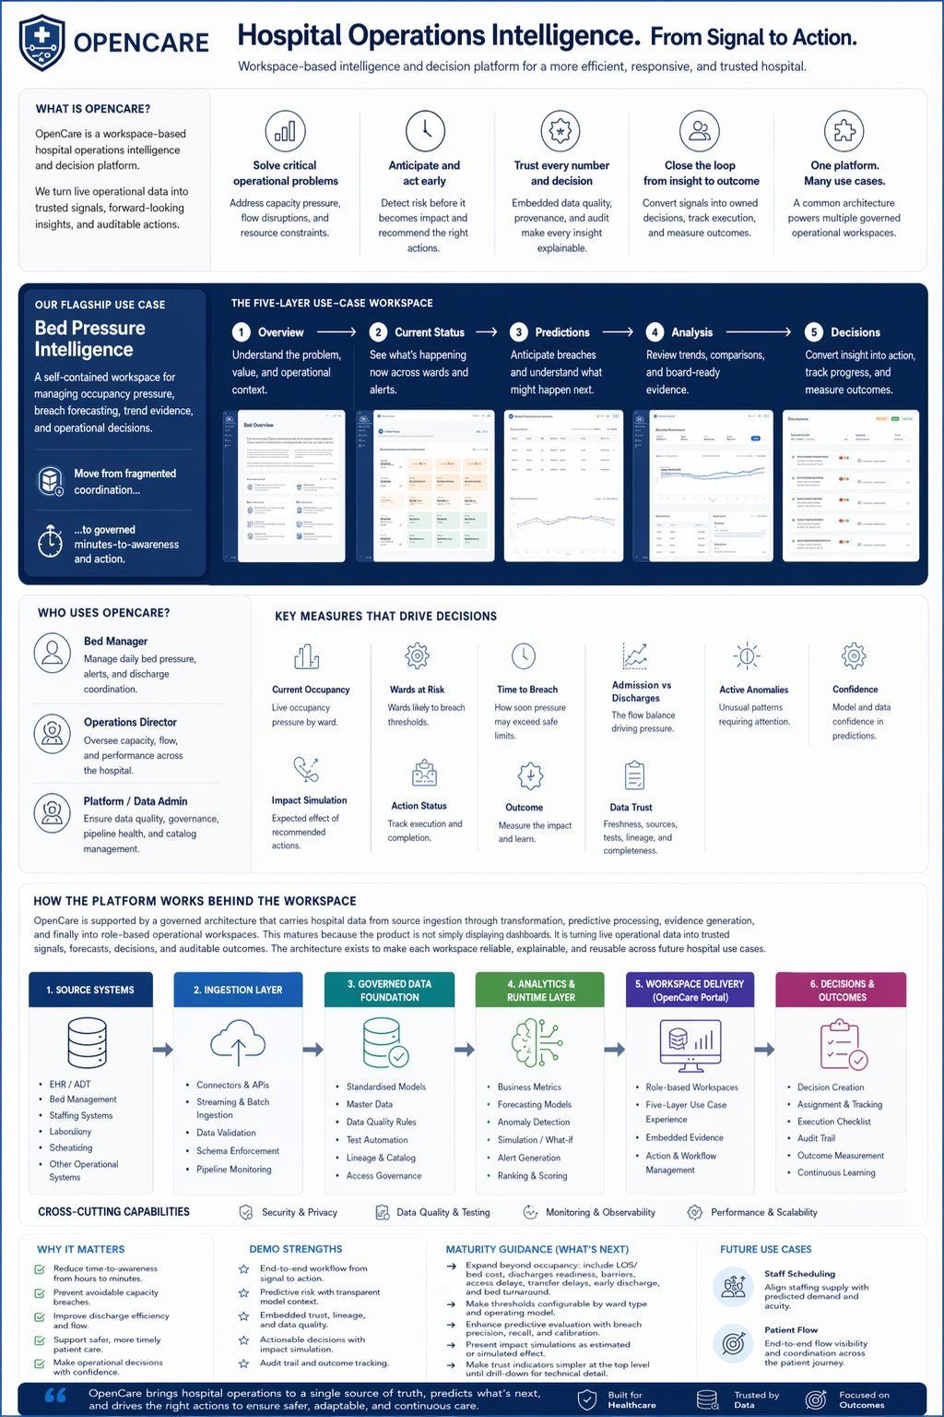

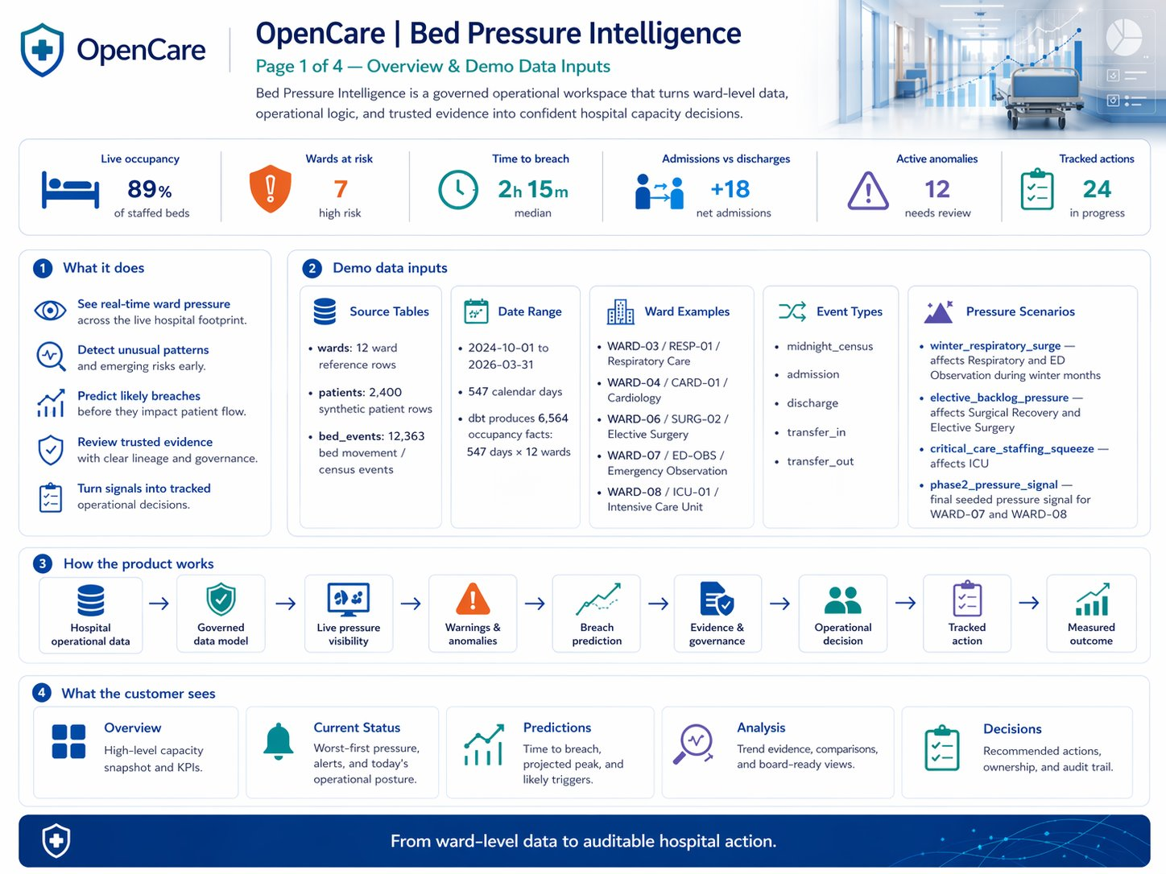

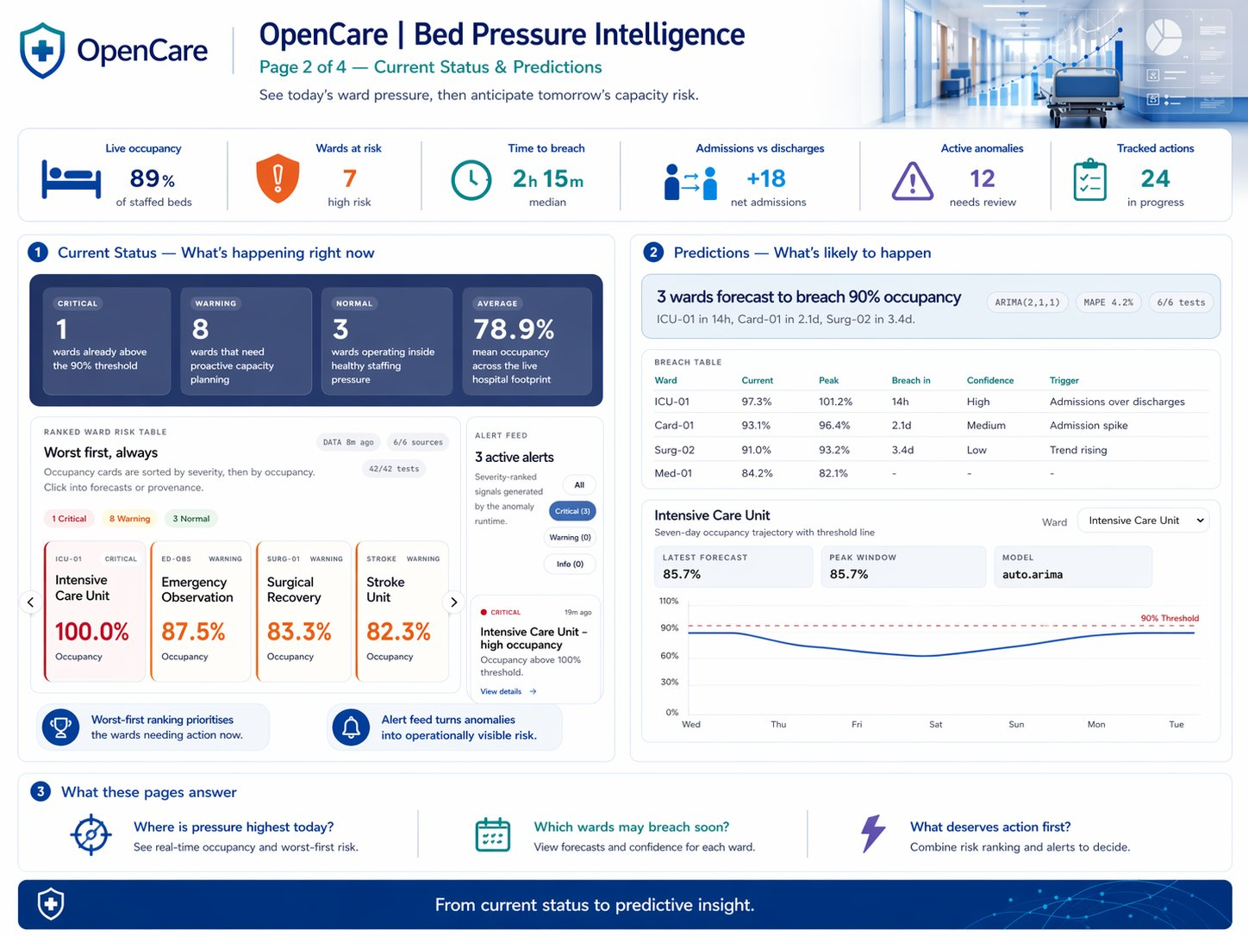

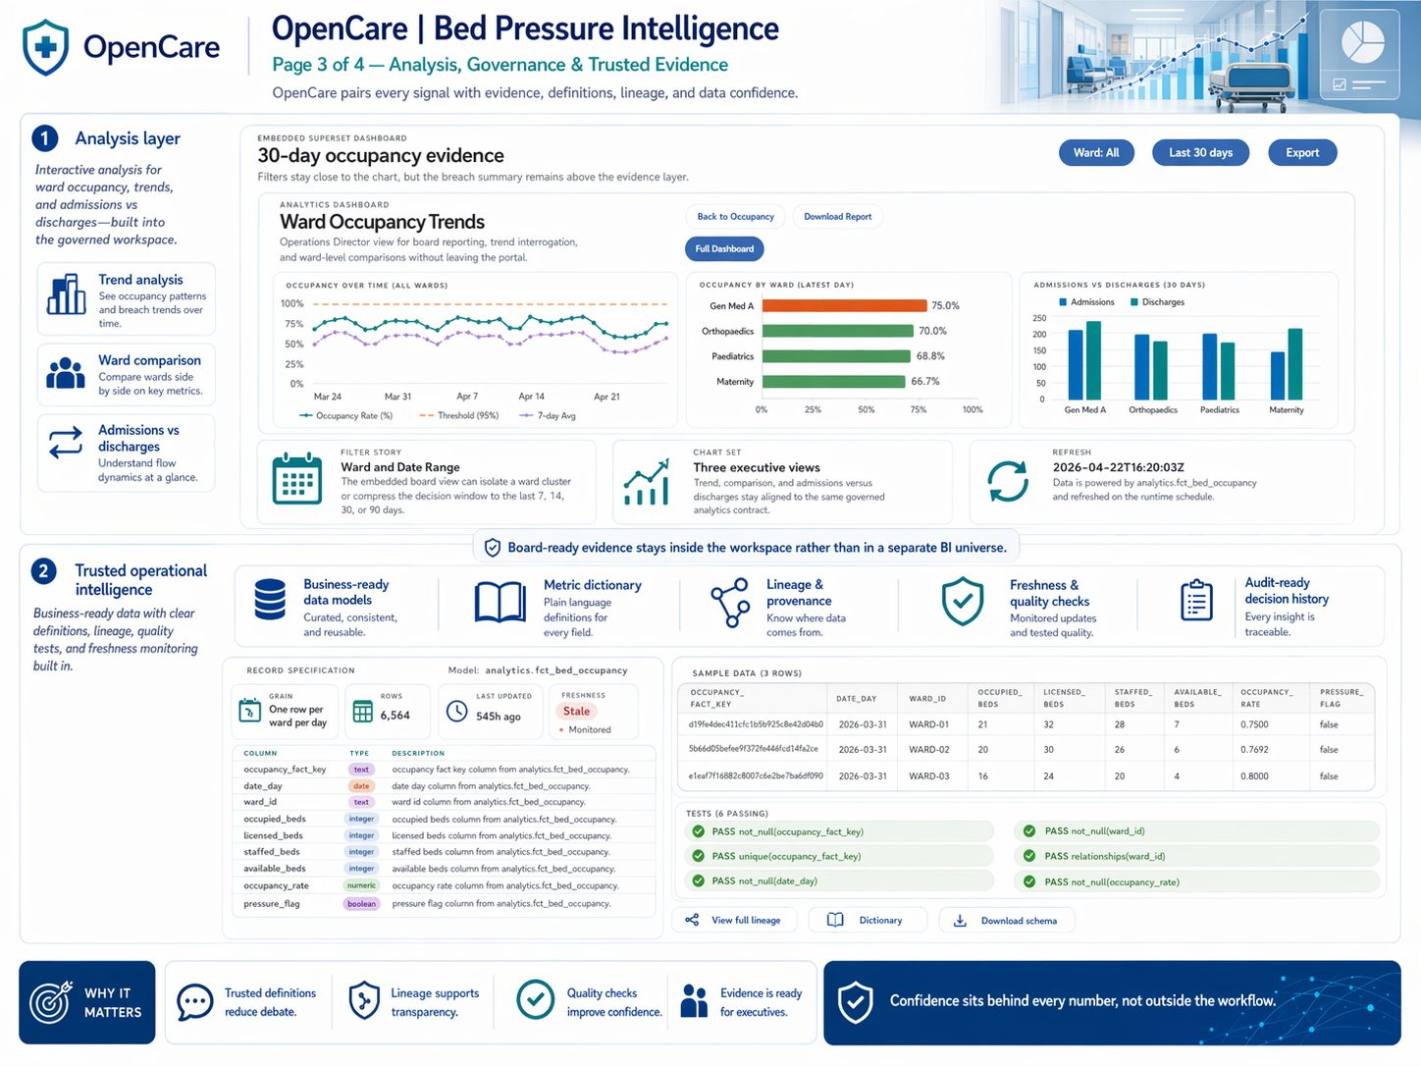

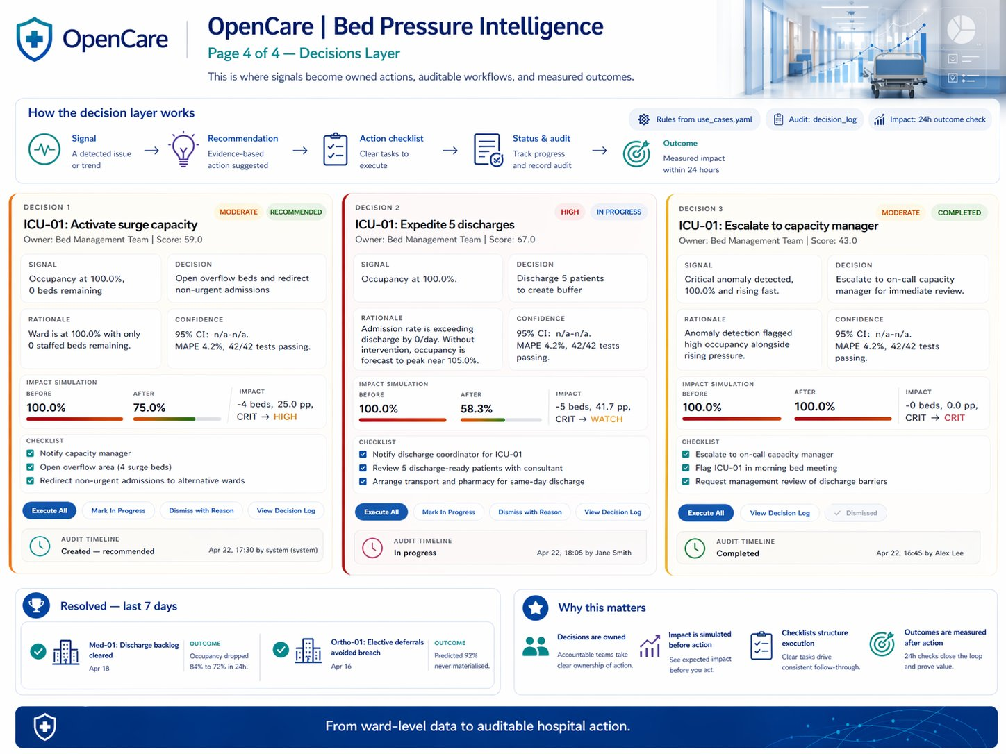

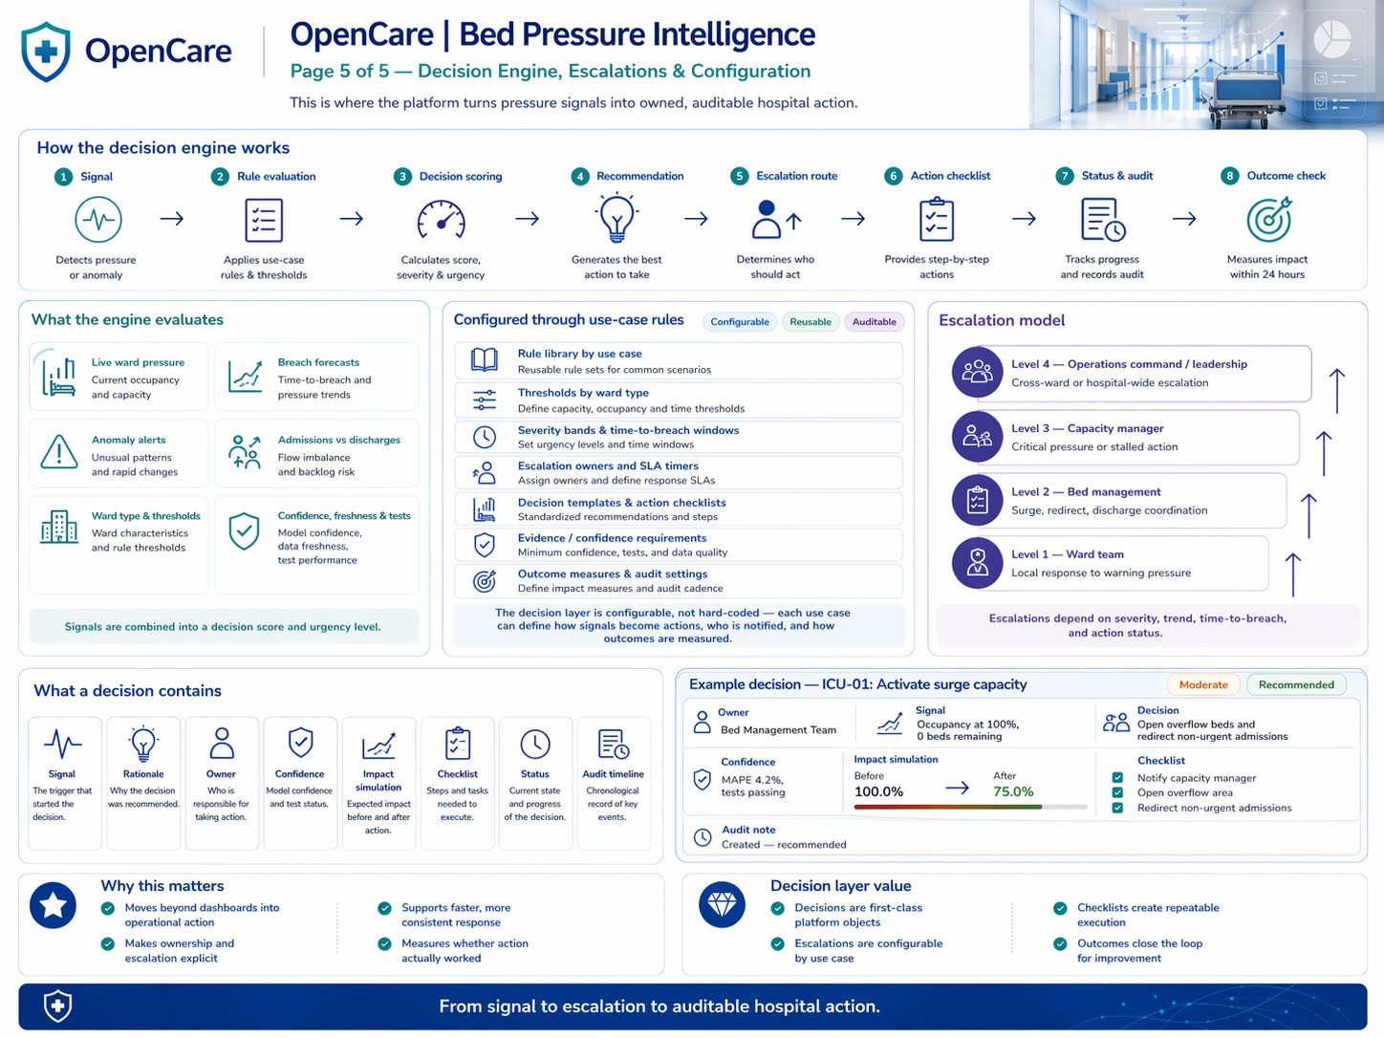

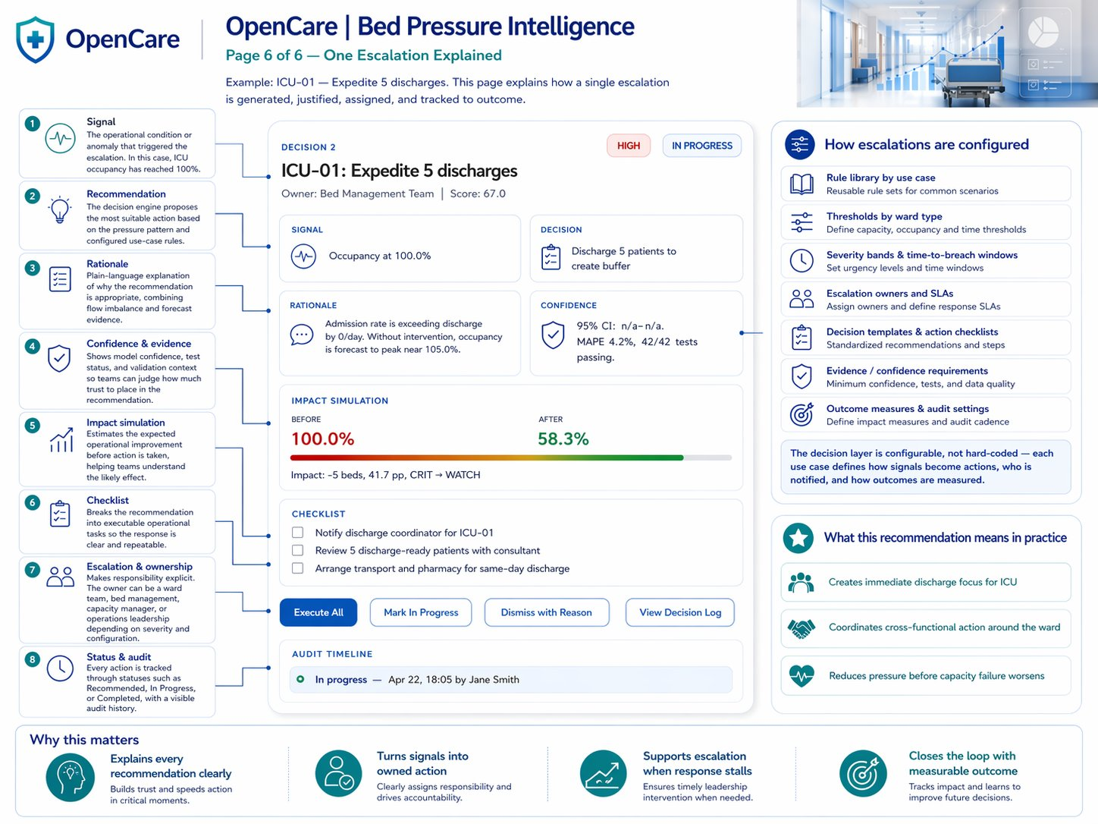

1. What OpenCare Is

OpenCare is a workspace-based hospital operations intelligence and decision platform. It converts operational data into governed, structured, auditable decisions — inside a single coherent environment.

Most hospital operations tools are built around visualisation. They present data well. What they have not solved is the step that follows: converting what is visible into a decision that is owned, tracked, and resolved. OpenCare is built around that step.
The product is structured as a catalogue of operational workspaces — one for each hospital operational domain. Each workspace is a self-contained module that takes a team through understanding a problem, monitoring its current state, anticipating risk, reviewing evidence, acting on it, and auditing the outcome. The first and most developed of these is Bed Pressure Intelligence.

What It Is Not
The platform is frequently described in terms that understate it. To be precise:
- Not a dashboard portal. Dashboards exist within OpenCare as evidence layers, but they are not the product. They serve the decision, not the other way around.
- Not a BI platform. Business intelligence answers questions. OpenCare supports decisions — a different and more operationally demanding objective.
- Not a clinical system. OpenCare operates in the operational layer: capacity, flow, staffing, scheduling. It does not make clinical diagnoses or treatment recommendations.
- Not a data warehouse. The underlying data infrastructure sits separately. OpenCare is the governance and decision layer placed on top of it.

The Workspace Architecture
Every module in OpenCare follows the same five-layer structure:

01  Overview | The operational context — why this module exists and who uses it

02  Current Status | Live operational position, ranked pressure, active alerts

03  Predictions | Forward-looking risk — breach forecasts, time to threshold, confidence

04  Analysis | Embedded evidence — trend views, ward comparison, export-ready for executive review

05  Decisions | Structured, owned, tracked, and auditable operational decisions

This structure is consistent across all present and future modules. A team familiar with the Bed Pressure workspace can immediately navigate Staff Scheduling or Patient Flow when those modules are live — reducing training burden and accelerating adoption.

2. Product Logic: Data to Decision

The end-to-end logic of OpenCare can be expressed as a single, connected chain. Every stage feeds the next. No stage is optional. The value of the platform is not in any single layer but in the coherence and completeness of the sequence.
Data | Operational and clinical data is ingested, validated, and profiled. Freshness, source coverage, and automated test results are tracked at the point of ingestion — before any user sees a number.
Signal | The platform converts raw data into operational signals: current occupancy, admission and discharge rates, anomaly detection, and active threshold alerts. Signal is the first thing a bed manager sees.
Prediction | Predictive models project forward risk. Which wards are likely to breach threshold? When? At what confidence? What is the likely trigger? Predictions are surfaced with model context visible — not as black-box outputs.
Evidence | Supporting trend data, ward comparisons, and historical context sit inside the workspace as an evidence layer. It is accessible when needed for review or briefing, but it does not dominate the operational view.
Decision | Signals and predictions are converted into structured operational decisions. Each decision carries an owner, urgency rating, rationale linked to the data, impact simulation, and execution checklist.
Action | Decisions translate into discrete operational steps. The checklist is visible inside the workspace, assigned, and tracked — not communicated informally via phone or verbal handover.
Outcome | When a decision is resolved, its outcome is recorded. This closes the loop between signal and response and begins the process of operational learning.
Audit | The full history — data lineage, model versions, decision rationale, and completion status — is preserved. Nothing is reconstructed after the fact; it is recorded as it happens.

The central design principle
The problem most hospital data tools have not solved is not visibility — it is accountability. A platform that shows the problem but does not create a system of record for the response leaves the most important part of the operational loop in people's heads. OpenCare is designed to close that loop.

3. Bed Pressure Intelligence: The Use Case

The Operational Problem
Bed pressure — the condition in which ward occupancy approaches or exceeds safe operational capacity — is one of the most consequential and most persistently mismanaged problems in acute hospital settings. It drives avoidable patient deterioration, contributes to discharge delays, increases emergency department boarding, and generates escalating operational risk for hospital management.
The challenge is not that bed pressure is invisible. Operations staff know it is happening. The challenge is that the systems available to manage it are routinely:
- Delayed. Occupancy data reflects earlier in the shift, not the current moment.
- Fragmented. Information is spread across PAS systems, nursing records, discharge coordinators, and verbal handovers.
- Reactive. Alerts fire after a threshold is breached, not before. By that point, the optimal intervention window has already passed.
- Undocumented. Decisions taken in response are unrecorded, unowned, and cannot be audited or learned from.

The consequence is that bed pressure management is almost entirely experience-driven. Skilled operations staff compensate through institutional knowledge, informal networks, and professional instinct. That is not a failure of competence — it is what happens when the tooling fails the person.

Who Uses the Workspace
The Bed Pressure Intelligence module serves three primary personas. Importantly, all three operate within the same workspace — they navigate to the layers most relevant to their role, not to a parallel product built for them separately.

Persona | Primary Layers Used | Core Operational Question
Bed Manager | Current Status, Decisions | Which wards need action right now, and what should I do?
Operations Director | Predictions, Analysis | Where is risk building, and what is the pattern across the hospital?
Platform / Data Admin | Overview, Trust Metadata | Is the data current, complete, and reliable enough to act on?

This shared-workspace model is architecturally significant. There is no 'executive version' and 'operational version' generating separate, potentially inconsistent views of the same situation. The evidence that informs a bed manager's decision is the same evidence an operations director sees in the analysis layer and a board reviewer sees in the audit trail.

4. The Five-Layer Workspace Model

Each layer of the workspace is designed to answer a specific operational question. Together they form a progression — from context, through live status and forward risk, to evidence and structured action.
01  Overview | Why does this module exist, and who is it for?

The Overview layer establishes the operational contract for the workspace. It explains the problem domain, the decision types the module supports, and the personas who use it. This is not a help page or a tutorial — it is a standing document that provides shared orientation for all users of the module.
Most data tools present information without context. The Overview layer ensures that everyone entering the workspace understands not just what the numbers mean, but why those numbers are being measured, what kind of response they are designed to prompt, and what decisions they support. This matters more in healthcare than in almost any other operating environment, because the cost of misinterpreted signals is high.
02  Current Status | What is the operational position right now?

Current Status is the operational landing page of the workspace. It is designed for the bed manager or operations coordinator who needs to understand, within the first thirty seconds, exactly where the pressure is and what is actively alerting.
What the user sees
- Worst-first ward ranking. Wards are sorted by composite pressure score, not alphabetically or geographically. The most critical situations surface immediately, without requiring the user to scan.
- Active anomalies and alerts. Signal-based alerts triggered when patterns deviate from expected ranges — distinct from simple threshold breaches, which only fire when it is already too late.
- Ward occupancy cards. Live occupancy position for each ward against its threshold, providing an at-a-glance comparison across the hospital.
- Admissions vs discharges balance. The flow ratio — the leading indicator of whether pressure is building or relieving. More powerful than a static occupancy number.
- Current operational posture. A hospital-wide summary read for the current moment, calibrated for rapid escalation decisions.

The worst-first design choice is not cosmetic. Most hospital dashboards default to alphabetical or geographical ward views because that is how the building is organised, not how risk is distributed. Ranking by severity means that a bed manager managing fifteen wards sees the four wards that need attention at the top, not buried in a scroll.
03  Predictions | Which wards are likely to breach threshold, and when?

The Predictions layer shifts the workspace from reactive monitoring to anticipatory management. It is operationally significant because the optimal window for intervention in bed pressure is before a breach, not after it.
What the user sees
- Ward-level breach risk. Which wards are on a trajectory toward threshold breach within the forecast window.
- Projected peak occupancy. The expected maximum occupancy level if current trajectory continues without intervention.
- Time to breach. A planning horizon that gives the operations team a window to act — not a retrospective alert.
- Confidence score. The model's self-assessed reliability for each prediction. Users can weight their response accordingly rather than treating all forecasts as equally reliable.
- Likely trigger. The model's assessment of the primary driver of the forecast — for example, low discharge rate, high admissions volume, or delayed transfers. This is operational context, not just a number.
- Model context. Model family and forecast error are visible, making predictions legible and interrogable — not black-box outputs to be accepted without question.

The decision to surface model context alongside predictions is a mature design choice. Hospital operations staff are trained to be appropriately sceptical of automated outputs. Making confidence and error metrics visible increases the probability that staff will engage with predictive signals rather than dismissing them as unaccountable automation.
04  Analysis | What does the evidence show over time?

The Analysis layer provides the evidence base for operational review, clinical governance, and executive reporting. Critically, it is evidence embedded inside the workspace — not a separate reporting tool that must be separately requested, built, and reconciled.
What the user sees
- Trend views. Occupancy and pressure patterns over defined time horizons — for operational pattern recognition and retrospective review.
- Ward comparison. Cross-ward performance benchmarking, enabling identification of persistent underperformers and relative anomalies.
- Admissions vs discharges over time. The structural driver of bed pressure trends, not just the current snapshot.
- Export-ready views. Formatted for use in operational reviews, executive presentations, or board packs — without requiring a separate BI export cycle.

In most hospitals, evidence for board or executive review is assembled manually by a BI analyst exporting data into a slide deck, reviewed hours or days after the operational event it describes. By embedding the analysis layer inside the workspace, OpenCare ensures that the evidence seen by executives is the same evidence that informed the operational decision in real time — not a parallel reconstruction of it. This matters for credibility, for speed, and for governance.

05  Decisions | What was decided, by whom, and what happened?

The Decisions layer is the most structurally distinctive feature of OpenCare. It converts operational signals into formal, owned, tracked, and auditable decisions — bridging the gap between intelligence and action that most hospital data tools leave completely unaddressed.
What the user sees
- Structured decision records. Each operational response is converted from the signals visible in Current Status and Predictions into a formal decision record with its own history and status.
- Owner and urgency. A named owner and an urgency/impact rating make accountability explicit and support prioritisation when multiple decisions are live simultaneously.
- Rationale. Each decision links directly to the data signal that prompted it — creating a traceable line from evidence to response.
- Impact simulation. A modelled estimate of the operational effect of the proposed action. Presented as a simulated projection, not a guarantee — which is the appropriate framing for this type of tool.
- Execution checklist. High-level decisions are translated into discrete operational steps, assigned and tracked within the workspace.
- Audit timeline. A record of when the decision was created, progressed, and resolved — supporting handover, incident review, and governance.
- Outcome. What actually happened as a result of the decision — creating a continuous operational learning loop.

The Decisions layer is what distinguishes OpenCare from a dashboard product. A dashboard tells you what is happening. The Decisions layer creates a system of record for what was done in response — and by whom. The difference matters for patient safety governance, CQC review, board accountability, and the long-term development of evidence-based operational practice.

5. Measures and Why They Matter

The following measures are visible or implied within the current demo. Each is assessed in terms of its operational rationale and its fitness for the demonstrated use case.

Current Status Measures
Measure | Operational Significance
Current Occupancy | The primary pressure indicator — the proportion of commissioned beds occupied at the time of data refresh. It is the right starting point for bed pressure analysis.
Wards Above Threshold | A hospital-wide count of wards operating above a defined pressure threshold. Provides the operational director with an immediate whole-hospital read.
Severity-Ranked Pressure | Wards ordered by composite pressure score, worst first. Eliminates the need to scan and surfaces critical situations without user effort.
Admissions vs Discharges | The flow balance — the leading indicator of whether pressure is building or relieving. More diagnostic than occupancy alone.
Active Anomalies | Signal-based alerts for patterns that deviate from expected ranges. Important because statistical anomalies can precede threshold breaches by hours.

Predictive Measures
Measure | Operational Significance
Forecast Breach Risk | The probability that a given ward will breach its pressure threshold within the forecast window. Enables anticipatory rather than reactive response.
Time to Breach | An estimated timeline for threshold breach. Gives the operations team a planning horizon — the single most operationally useful output of any predictive model.
Projected Peak Occupancy | The expected maximum occupancy level if current trajectory continues unchecked. Supports decision about when and how aggressively to intervene.
Confidence | The model's reliability assessment for each prediction. Critical for calibrating response — a low-confidence high-risk forecast calls for verification, not immediate escalation.
Likely Trigger | The primary driver of the forecast trajectory. Tells the operations team whether to act on discharge, admissions, transfers, or another lever — not just that pressure is building.

Trust and Governance Measures
Measure | Operational Significance
Data Freshness | Timestamp of the most recent data load. Tells users whether the numbers are current — a prerequisite for acting on them with confidence.
Source Coverage | Proportion of expected source systems that contributed to the current dataset. Flags gaps in the data picture before they cause misinterpretation.
Tests Passed | Results of automated data quality checks on the most recent ingestion. Provides confidence in integrity without requiring users to access the data platform.
Model Evidence | Model family, version, and forecast error — making the predictive layer auditable and interrogable.
Decision Score | A composite indicator of the evidential strength underlying a given decision recommendation.
Impact Simulation | A modelled estimate of the operational effect of a proposed action. Presented as a projection, explicitly not a guarantee.
Action / Outcome | The tracked state and recorded result of each decision — creating a continuous audit loop from signal to resolution.

Measures to Add in Production
The current demo is appropriately focused on occupancy as its primary signal. Occupancy is the right starting point — visible, measurable, and universally understood. In a production deployment, the following additional measures would materially deepen the operational picture:
- Discharge readiness and discharge barriers. Distinguishes patients who could be discharged from those who cannot, enabling targeted intervention rather than generic pressure management.
- Length of stay and excess bed days. Identifies patients occupying beds beyond clinical need — often the primary driver of persistent occupancy pressure.
- Transfer delay tracking. Quantifies the operational impact of delayed transfers to community, step-down, or mental health settings.
- ED boarding time. Measures the upstream pressure exerted on ward capacity by emergency department crowding — often invisible to ward-level occupancy metrics.
- Early discharge timing. Tracks the proportion of discharges completed before noon — a recognised operational efficiency indicator with direct impact on admissions capacity.
- Bed turnaround time. The interval between patient departure and the bed being available for the next admission — a key throughput measure often ignored in occupancy-only models.

Why this matters
Occupancy is a correct starting point but an incomplete proxy for flow health. Pressure caused by high admissions volume requires a different response from pressure caused by slow discharge, poor turnaround, or upstream blockage. Without these additional measures, the platform can identify that pressure exists but not reliably diagnose why — limiting the precision of decision recommendations.

6. Trust, Governance, and Evidence

One of the structurally distinctive features of OpenCare is that trust and governance metadata is embedded inside the workspace itself — visible to operational users, not confined to back-end documentation or accessible only to data engineers.
This is not a trivial design choice. In most hospital data environments, a question about data quality requires a request to a data team, typically resolved over hours or days. The operational consequence is that users either proceed with uncertain confidence or delay action pending verification — both of which have cost.
The differentiator
A bed manager who sees that source coverage is 94% and all quality tests have passed can act on the numbers with confidence. A manager who sees that source coverage is 61% knows to verify before escalating. That distinction — made visible at the moment of decision, not retrospectively — is operationally and clinically significant.

The specific governance elements embedded in the current workspace include:
- Data freshness. The timestamp of the most recent data load. The most fundamental trust indicator — users should never have to guess whether they are looking at current information.
- Source coverage. The proportion of expected source systems present in the current dataset. Flags incomplete pictures before they cause misinterpretation.
- Tests passed. Results of automated data quality checks run on ingestion — providing integrity confidence without requiring access to the data platform.
- Schema and record specification. Visible data structure for technically proficient users who need to understand what exactly is being measured.
- Lineage. Tracing which source systems contributed to each measure, providing accountability for data provenance.
- Audit history. A preserved record of previous decisions, data states, and model outputs — available for governance review without reconstruction.

For regulatory and governance purposes, this embedded audit and lineage trail provides the foundation for demonstrating that operational decisions were made on the basis of adequate data — an increasingly important requirement as digital care environments become subject to clinical governance and CQC review.

7. Decision Layer and Actionability

The difference between a hospital that has good operational intelligence and one that has good operational outcomes is, in most cases, the quality of the system that connects them. The Decisions layer is designed to be that system.

The Gap That Persists
Most hospital data tools are designed to improve awareness. They succeed. Operations staff can see more, faster, with greater granularity. The gap that persists is not information — it is structured response.
When a dashboard shows that a ward is approaching capacity, the typical sequence is: a nurse or bed manager recognises the signal, makes a judgement call based on experience, communicates informally by phone or verbal handover, takes an action that is nowhere recorded, and produces an outcome that is known only to those directly involved. The dashboard did its job. Everything after it did not.

What the Decisions Layer Provides
OpenCare converts signals into formal decision records. Each record carries a named owner, so accountability is unambiguous. It carries an urgency and impact rating, so prioritisation is explicit when multiple decisions are active simultaneously. It carries a rationale drawn directly from the data — creating a traceable link between signal and response. It carries an execution checklist, so the decision becomes operational immediately. And it carries an audit timeline and outcome record — creating a closed-loop system of record.
On impact simulation
The impact simulation feature — projecting the estimated operational effect of a proposed action — is one of the most ambitious elements of the Decisions layer. In the current demo it provides illustrative directional guidance. In production, it would require calibration against ward-specific historical data and operating parameters. It should always be presented as a modelled projection, not a prediction of outcome. The design intent is correct; the implementation pathway requires explicit calibration work.

The strategic value of the Decisions layer compounds over time. The accumulated record of decisions — what was decided, by whom, based on what signal, with what outcome — becomes an institutional operational learning resource. Patterns become visible. Recurring interventions can be systematised. Ineffective responses can be identified and replaced. This is the basis for evidence-based operational improvement — not improvement from assumption, but from record.

8. Demo Strengths

The following is an assessment of what is already credible and commercially strong in the OpenCare demo.

Architecture and Structure
- The workspace model is coherent and distinctive. The five-layer structure — Overview through Decisions — is immediately understandable and maps cleanly onto how hospital operations actually functions. It is not a set of screens; it is a logical journey.
- The use case selection is well-judged. Bed pressure is the highest-frequency, highest-consequence problem in acute hospital operations, and it is consistently poorly served by existing tools. Starting here is correct.
- The shared-workspace model is architecturally sound. The ability for a bed manager, operations director, and data admin to operate in the same module at different layers — without parallel reporting systems — is a genuine operational and commercial advantage.

Operational Design Choices
- Worst-first severity ranking is a strong decision. It reflects how operational risk actually works, not how hospital buildings are organised.
- The Predictions layer surfaces model context. Making confidence, model family, and forecast error visible is a mature and operationally intelligent design choice. It is the difference between a prediction tool and a credible decision aid.
- Embedded trust metadata is a genuine differentiator. No mainstream hospital operations tool surfaces data freshness, source coverage, and test status inline. This is the right approach and it solves a real operational problem.

The Decisions Layer
- This is the most commercially original element of the product. No standard hospital dashboard or BI tool provides this level of decision accountability infrastructure at the operational level. Owned, tracked, auditable decisions — with rationale linked to data — is a structural gap in the current market that OpenCare is designed to fill.
- The audit timeline closes a loop that most tools leave open. The ability to record outcome against a decision — and preserve that record — is the foundation of operational governance and continuous improvement.

9. Criticism and Maturity Guidance

The following identifies areas for development and refinement as OpenCare moves from proof of concept toward production. These are not weaknesses in the product concept — they are the expected next steps in a coherent maturation pathway.

Flow Completeness
The current demo is occupancy-centric. Occupancy is the right starting point, but it is an incomplete proxy for flow health in a production hospital environment. Pressure caused by high admissions volume requires a different response from pressure caused by slow discharge, poor bed turnaround, or upstream blockage from the ED. Without the additional flow measures outlined in Section 5, the platform can identify that pressure exists but cannot reliably diagnose why — which limits the precision of decision recommendations and the credibility of impact simulations.
Recommended next step
Add discharge readiness, LOS and excess bed days, ED boarding, and bed turnaround as core measures in the next version of the workspace. These convert an occupancy view into a flow health diagnosis.

Configurable Thresholds
The current demo implies fixed occupancy thresholds. In production, thresholds must be configurable by ward type, staffing model, and operational context. A surgical ward, a medical assessment unit, and a step-down critical care unit have materially different safe capacity parameters. Fixed thresholds applied uniformly will produce both false positives and false negatives — eroding the operational trust that the platform depends on.
Recommended next step
Build threshold configuration into the Platform Admin layer of the workspace. Allow thresholds to vary by ward type and shift pattern, with change history preserved for governance.

Impact Simulation Framing
The impact simulation feature is the right concept, but it requires careful production framing. In the current demo it is illustrative. In a live deployment it will be interrogated by operations directors and used as justification for escalation decisions. It must be presented consistently as a modelled estimate — not as a prediction of outcome — and it must be calibrated against ward-specific historical data before it can be operationally reliable.
Recommended next step
Add explicit 'estimated effect' labelling to all simulation outputs. Build calibration history into the model evidence layer so users can assess how reliable a given simulation is for a given ward type.

Trust Metadata Accessibility
The trust indicators currently visible in the workspace are well-suited to a technically literate user. For a bed manager or ward coordinator, the most operationally useful format may be a simplified single RAG indicator — green/amber/red — with the detailed freshness, coverage, and test metrics available on drill-down rather than always visible. This is not a reduction in governance rigour; it is appropriate information architecture for the operational context.
Recommended next step
Introduce a summarised trust status indicator at the top of Current Status and Predictions, with the full trust panel available to users who need it. This serves both the operational user and the data admin without compromising either.

Alert Fatigue
As the platform matures and more wards are monitored, alert logic will need to distinguish between sustained pressure and transient spikes. Undifferentiated alerting — every anomaly generating the same signal — is one of the fastest routes to operational distrust of an automated system. Alert thresholds, duration requirements, and severity tiers should be built into the alerting model from the outset.

10. Future Extensibility

One of the most commercially significant features of the OpenCare architecture is that it is domain-independent. The five-layer workspace model applies equally well to any bounded hospital operational domain that requires monitoring, prediction, evidence, and decision accountability.

Staff Scheduling
The operational logic of staff scheduling maps directly onto the OpenCare workspace structure. Current staffing positions need to be visible against demand (Current Status). Predictive models can anticipate shortfall before it becomes critical (Predictions). Evidence views support rostering decisions and escalation (Analysis). And decisions about temporary staffing, bank and agency deployment, and shift reallocation can be owned, tracked, and audited (Decisions). The workspace architecture requires no structural change — it requires domain-specific measures and data sourcing.

Patient Flow
Patient flow intelligence — tracking patient movement through ED, assessment units, wards, and discharge pathways — is the logical extension of bed pressure intelligence, operating at higher complexity and across more source systems. The workspace model provides the right structural container. In particular, the Decisions layer becomes substantially more powerful in a patient flow context, where coordinated action across multiple teams (ED, bed management, discharge coordination, community services) is required and accountability is frequently unclear.
Platform architecture advantage
The key commercial implication of this extensibility is that OpenCare is not a point solution. Each new module added to the platform increases its operational coverage and strategic value within a hospital system — without requiring a fundamentally different product architecture. A hospital that adopts OpenCare for bed pressure management acquires a platform infrastructure, not a single-use tool. Every additional module returns value to all previous investment.

The consistency of the workspace structure across modules also reduces adoption friction materially. Operations staff who are familiar with the Bed Pressure workspace will navigate Staff Scheduling immediately, because the structure is the same. In environments where training time is limited and staff turnover is high, that consistency is a practical operational advantage with real commercial value.

Closing Statement

Hospital operations teams are not short of data. What they are short of is a system that connects signal to decision — and holds people accountable for the response.
OpenCare is designed to be that system.

The choice of Bed Pressure Intelligence as the flagship use case is well-judged. It is the highest-frequency, highest-consequence operational problem in acute hospital settings, and a domain where existing tools — dashboards, PAS reports, informal escalation — consistently fail the people who use them.
The workspace architecture is coherent. The product logic — from data to signal to prediction to evidence to decision to outcome to audit — is sound and complete. The Decisions layer addresses a structural gap in hospital operations tooling that no mainstream product currently fills. The embedded governance model is the right approach to a problem that most platforms either ignore or relegate to back-end documentation.
The demo is a strong proof of concept. The maturity pathway is clear. The areas that require further development — flow completeness, configurable thresholds, impact simulation calibration — are refinements on a solid foundation, not corrections to a flawed premise.
OpenCare addresses a problem that is real, recurring, and commercially significant in every acute hospital operating today. The approach is valid. The direction is strong.

OpenCare · Hospital Operations Intelligence & Decision Platform · Concept Document · Not for Clinical Use

APPENDIX
Production Readiness Guide
Bed Pressure Intelligence: From Demo to Real Use Case
A structured guide for the product owner or project manager responsible for taking the Bed Pressure Intelligence demo into production. Each section identifies what is currently demo-grade, what needs to change, and what work is involved.

How to use this guide
Each of the six sections below corresponds to a production readiness domain. For each domain you will find: the current demo status, a plain-language description of what needs to change, and the specific work items a product owner would need to plan and prioritise. Work items are flagged as Foundation (must be done before go-live), Enhancement (adds significant operational value), or Governance (required for clinical governance and audit compliance).

🔴 Demo only | 🟡 Partial / needs work | 🟢 Production-ready | 📋 Work item type key
Illustrative data, no real hospital integration | Structure exists but requires real-world calibration | Can be deployed as-is with configuration | F = Foundation E = Enhancement G = Governance

A. Data Requirements

Current demo status  Synthetic data only. 2,400 simulated patient rows, 12 ward reference rows, and 12,363 bed movement events generated to illustrate the workspace. No connection to any real hospital system. | Production requirement  Real-time or near-real-time feeds from the hospital's PAS/ADT system, bed management system, and nursing census. Minimum refresh: 15-minute intervals for operational use.

Core Data Sources Required
Source | What Is Needed
PAS / ADT | Patient admission, discharge, and transfer events in real time. Must include ward, bed, patient ID (pseudonymised), admission time, expected discharge date, and transfer-out destination.
Bed management system | Live bed state: occupied, available, blocked, closed. Some hospitals hold this in their PAS; others in a separate bed management tool (e.g. Nervecentre, Cerner, Allocate).
Midnight census | Daily snapshot of occupied beds per ward. Required for trending, SLA benchmarking, and board reporting — even if intraday feeds exist.
Ward reference data | Static ward configuration: licensed beds, staffed beds, ward type, specialty, threshold settings. Must be maintainable by the Platform Admin without a developer.
Discharge readiness | Clinician-flagged discharge readiness status per patient — the single most valuable addition beyond basic occupancy. Usually held in a ward coordination system or manual board.
Staffing levels | Shift-level staffing actuals per ward. Needed to contextualise occupancy — a ward at 90% with full staffing is a different risk profile from one at 80% short-staffed.

Work Items — Data
Ref | Work Item
D1 · F | Map the hospital's PAS/ADT event structure to the OpenCare bed_events schema. Document field-by-field transformation rules.
D2 · F | Build and test the Airbyte connector or equivalent ETL pipeline for the PAS/ADT feed. Validate event completeness and timing against known admissions.
D3 · F | Replace synthetic ward reference data with real ward configuration. Build a UI or config file for the Platform Admin to maintain ward thresholds without code changes.
D4 · F | Establish and test data refresh cadence. Define alerting for late or failed data loads — a missing refresh must be visible in the trust panel before any operational user acts on stale data.
D5 · E | Integrate discharge readiness status feed. Define the source system, mapping, and refresh rate. This is the highest-value data addition after core occupancy.
D6 · E | Add length of stay and excess bed days calculation to the analytics schema, derived from admission date and expected discharge date in the PAS feed.
D7 · G | Implement data pseudonymisation and access controls at ingestion. No patient-identifiable data should be visible in the operational workspace without explicit role-based authorisation.

B. Technical Changes

Demo vs production gap
The demo runs on a self-contained local stack (K3s, synthetic MySQL, MinIO) with hardcoded data seeds and scheduled CronJobs running on fixed intervals. A production deployment requires a resilient, observable, multi-tenant-ready infrastructure with monitoring, failure recovery, and zero-downtime deployment capability.

Infrastructure
Component | Change Required
Database | Move from demo MySQL to a production-grade PostgreSQL instance with connection pooling, automated backups, point-in-time recovery, and monitored replication lag.
Object storage | Replace MinIO (demo) with hospital-approved object storage or a cloud equivalent. Define retention policies for raw data, model outputs, and audit logs.
Kubernetes | Harden the K3s demo cluster or migrate to a managed Kubernetes service. Define resource limits, pod restart policies, and horizontal scaling for the API and CronJob workloads.
Secrets management | Replace hardcoded credentials and environment files with a secrets manager (Vault, AWS Secrets Manager, or equivalent). No credentials in version control.
Monitoring | Instrument all services with health checks, latency metrics, and error rate alerting. The Platform Admin must know about a failed CronJob before the operational team notices stale data.
CI/CD pipeline | Extend the GitHub Actions pipeline to include automated integration tests, schema migration checks, and a staging environment that mirrors production before any release.

Application Layer
Component | Change Required
Authentication | Integrate with the hospital's identity provider (Active Directory, NHS Identity, or SSO). Role-based access control must distinguish Bed Manager, Operations Director, and Platform Admin permissions.
Multi-ward / multi-site | The demo models 12 wards in a single site. Production must support configurable ward sets, the ability to filter by site or division, and a hospital-wide summary view.
API rate limiting | Add rate limiting and request logging to the FastAPI layer. In a multi-user production environment, uncontrolled query volume can degrade performance for all users simultaneously.
Frontend performance | The Next.js portal must be tested under concurrent user load. Identify and optimise any components that block render on large ward datasets.
Superset configuration | Migrate the embedded Superset dashboards from demo data sources to the production analytics schema. Test filter interactions, export functionality, and permission alignment with the portal's auth layer.

Work Items — Technical
Ref | Work Item
T1 · F | Define the target hosting environment with the hospital IT or cloud infrastructure team. Document network, security, and data residency requirements before any infrastructure build begins.
T2 · F | Migrate database to production PostgreSQL. Write and test schema migration scripts. Validate against demo data before switching real feeds.
T3 · F | Implement SSO / Active Directory integration. Define and test RBAC roles: Bed Manager (read + decisions), Operations Director (read + analysis export), Platform Admin (full config).
T4 · F | Implement secrets management. Audit all environment variables and hardcoded values in the demo stack and migrate each to the secrets store.
T5 · F | Set up monitoring and alerting for all CronJobs, API endpoints, and data pipeline steps. Define SLAs for data freshness and alert thresholds for operational degradation.
T6 · E | Build a staging environment that mirrors production. All releases must pass staging validation before deployment. Define a rollback procedure.
T7 · E | Load-test the API and portal under expected concurrent user counts. Define performance baselines and identify bottlenecks before go-live.
T8 · G | Conduct a penetration test or security review of the API layer and portal before connecting to any real hospital data. Document findings and remediation.

C. Clinical and Operational Changes

The demo uses illustrative thresholds, generic ward types, and fixed pressure scenarios designed to demonstrate the workspace logic. A production deployment must reflect the real operational parameters of the specific hospital — and those parameters vary significantly by ward type, staffing model, and time of day.

Thresholds and Pressure Definitions
Parameter | Demo Status → Production Requirement
Occupancy threshold | Demo uses a fixed 90% threshold for all wards. Production requires configurable thresholds by ward type: acute medical wards typically operate at 85–92%, ICU at 80–85%, surgical at 88–95%. Thresholds should also vary by day of week and operational model.
Staffed vs licensed beds | Demo uses a single bed count. Production must distinguish licensed beds (total capacity), staffed beds (operable with current staffing), and available beds (not blocked or undergoing deep clean). These three numbers tell different operational stories.
Pressure severity bands | Demo uses Critical / Warning / Normal. Production should allow the hospital to define band names, colours, and trigger conditions to match their existing escalation framework — not impose a new one.
Anomaly sensitivity | Demo anomaly detection uses default model parameters. Production requires tuning per ward: a ward with high natural occupancy variance (e.g. ED observation) needs different sensitivity settings from a stable elective ward.
Time to breach window | Demo uses a fixed forecast horizon. Production should allow configuration of the forecast window (e.g. 4h, 8h, 24h) by ward type and use case context — a bed manager needs a 4-hour horizon; an operations director may want 24 hours.

Operational Measures to Add
The following measures are absent from the demo but are essential for a clinically credible production system. Each is listed with its data dependency and the operational question it answers.
Measure | Data Dependency / Operational Question
Discharge readiness rate | PAS + ward coordination system. Answers: of all occupied beds, how many patients could be discharged today if barriers were removed?
Discharge barriers by type | Ward coordination or nursing system. Answers: why are patients not being discharged — transport, TTO, family, awaiting assessment, placement delay?
Excess bed days | PAS (admission date + expected discharge date). Answers: how many patients have exceeded their expected LOS, and by how much?
ED boarding time | ED system + PAS. Answers: how many patients are waiting in ED for an inpatient bed, and for how long? This is often the earliest signal of building ward pressure.
Early discharge rate | PAS discharge timestamps. Answers: what proportion of discharges are completed before noon — a primary operational lever for releasing beds for afternoon admissions.
Bed turnaround time | Bed management system (departure time + next admission time). Answers: how long between a patient leaving and the bed becoming available? Identifies cleaning and portering bottlenecks.
Transfer delay | PAS + community/mental health system. Answers: how many patients are medically fit but waiting for a transfer to community, step-down, or mental health placement?

Work Items — Clinical and Operational
Ref | Work Item
C1 · F | Facilitate a configuration workshop with the Bed Manager, Operations Director, and ward leads to define ward-specific thresholds, severity bands, and forecast windows. Document agreed values for each ward and operating model.
C2 · F | Replace all demo ward reference data with real ward configuration. Include ward type, specialty, threshold, staffed beds, licensed beds, and responsible escalation owner.
C3 · F | Validate anomaly detection model sensitivity against historical data for each ward type. Adjust parameters to reflect real occupancy variance before enabling live alerts.
C4 · E | Integrate discharge readiness status from the ward coordination system. This is the single highest-value clinical data addition and the most frequently requested operational measure in bed management.
C5 · E | Add excess bed days calculation and surface it in the Current Status and Predictions layers. Flag wards where excess LOS is a primary driver of occupancy pressure.
C6 · E | Integrate ED boarding time as a leading indicator in the Current Status layer. Wards likely to receive ED boarders should be flagged before the transfer is initiated.
C7 · G | Conduct a clinical safety review of all operational measures and their definitions with the hospital's clinical governance lead. Any measure that could influence clinical decisions must be validated against the hospital's approved definitions.

D. Governance and Trust

The demo embeds governance metadata — freshness, test coverage, lineage — as an architectural principle. That principle is correct and should be preserved in production. What changes is the depth, reliability, and accountability of those signals. In a production hospital environment, trust metadata must be accurate enough to stake an operational decision on.

Trust Metadata — Demo vs Production
Trust Signal | Demo Status → Production Requirement
Data freshness | Demo shows a static freshness timestamp from the last synthetic data seed. Production must show the actual time of the most recent successful data load from each source system, with a per-source breakdown and a visible alert if any source is overdue.
Source coverage | Demo shows a fixed 6/6 source coverage value. Production must calculate this dynamically based on expected vs received source feeds in each refresh cycle. A missing feed must trigger an amber or red trust indicator before any user acts on the data.
Tests passed | Demo shows 42/42 tests passing on synthetic data. Production dbt tests must be run on every real data load, with results surfaced in the trust panel within minutes of ingestion. Failed tests must block downstream model runs or flag outputs as unvalidated.
Lineage | Demo shows static lineage documentation. Production lineage must be live — automatically updated on each dbt run, traceable from every metric back to its source table and transformation step.
Model accuracy | Demo shows a fixed MAPE and test count. Production model accuracy must be calculated on a rolling basis against actual outcomes, updated as new data arrives, and surfaced with a trend indicator so degrading model performance is visible before it causes operational harm.
Audit trail | Demo shows illustrative decision history. Production audit trail must be append-only, tamper-evident, and retained for the period required by the hospital's data governance and records management policy.

Governance Processes Required
Process | What Is Needed
Data ownership register | A formally maintained register of who owns each data source feeding OpenCare, who is responsible for quality, and what the agreed SLA is for data delivery. Required before go-live.
Metric definitions catalogue | All measures shown in the workspace must have a formally agreed plain-language definition, a technical specification, an owner, and a review date. The demo metric dictionary is illustrative — production requires formal sign-off.
Change management process | Any change to a threshold, measure definition, or model parameter in production must follow a documented change process with approval, testing, and audit log entry. Ad-hoc changes to production configuration must not be possible.
Clinical governance review | The workspace must be reviewed by the hospital's clinical governance or patient safety team before go-live. The review should confirm that no output of the workspace could be misinterpreted as a clinical recommendation.
Data protection impact assessment | A DPIA must be completed before any real patient-linked data (even pseudonymised) enters the platform. This is a legal requirement under UK GDPR and NHS data governance frameworks.

Work Items — Governance and Trust
Ref | Work Item
G1 · G | Complete a Data Protection Impact Assessment (DPIA) covering all data flows from source systems through to the OpenCare workspace. Obtain sign-off from the hospital's Data Protection Officer before connecting real data.
G2 · G | Produce and obtain sign-off on a formal metric definitions catalogue. Every measure in the workspace must have an agreed definition before go-live.
G3 · F | Implement dynamic freshness and source coverage calculation in the trust panel. Test that a simulated source failure triggers an amber/red trust indicator within one refresh cycle.
G4 · F | Configure dbt tests to run on every production data load. Implement logic to flag model outputs as unvalidated when upstream tests fail.
G5 · F | Implement append-only audit logging for all decisions, status changes, and configuration modifications. Define and test the retention period and access controls for audit records.
G6 · E | Build a rolling model accuracy tracker that recalculates MAPE and other performance metrics against actual outcomes as new data arrives. Surface accuracy trends in the trust panel.
G7 · G | Conduct clinical governance review of the workspace with the hospital's patient safety and clinical informatics leads. Document review findings and any required changes before go-live.

E. Decision Layer

The Decisions layer is the most architecturally distinctive feature of OpenCare and the element that most clearly separates it from a dashboard product. In the demo it operates on synthetic signals with illustrative rules and fixed escalation routes. In production, every aspect of the decision layer must be configurable, calibrated, and trusted by the operational staff who act on its outputs.

Decision Engine — Demo vs Production
Component | Demo Status → Production Requirement
Decision rules | Demo uses hardcoded rules in use_cases.yaml. Production requires a rule management interface that allows the Platform Admin to create, edit, version, and audit rules without code changes. Rules must be testable in a sandbox before activation.
Decision scoring | Demo calculates a fixed score per decision. Production scoring must be calibrated against historical pressure events and operational outcomes — not arbitrary weights. Scoring logic must be documented and explainable to clinical governance reviewers.
Impact simulation | Demo shows illustrative before/after occupancy estimates. Production impact simulation requires calibration against ward-specific historical data. Every simulation output must be labelled as an estimate with a visible confidence range — never presented as a guaranteed outcome.
Escalation routing | Demo assigns decisions to a fixed 'Bed Management Team' owner. Production requires a configurable escalation matrix: who receives a decision at each severity level, what the SLA is for acknowledgement, and what happens if the SLA is missed.
Notification delivery | Demo logs notifications without sending them. Production requires working SMTP email delivery, optionally extended to SMS or in-app push notification, with delivery confirmation logging and fallback on failure.
Outcome measurement | Demo records illustrative outcomes. Production must measure actual operational outcomes — did occupancy decrease after the action was taken? By how much? Within what timeframe? This feedback loop is what makes the decision layer improve over time.

Configurable Decision Templates
Each use case should ship with a set of pre-built decision templates covering the most common operational responses. Templates should be reusable, editable by the Platform Admin, and linked to specific signal types. The following are the minimum templates required for the Bed Pressure use case:
Template | Trigger Condition | Default Owner | SLA
Expedite discharges | Occupancy > threshold + low discharge rate | Bed Manager | 2 hours
Open escalation beds | Occupancy at 100% + breach imminent | Operations Director | 1 hour
Redirect admissions | Ward at capacity + alternative ward available | Bed Manager | 30 minutes
Activate surge capacity | Multiple wards breaching simultaneously | Ops Command | Immediate
Escalate to capacity manager | Critical anomaly + no action taken | Capacity Manager | 1 hour
Flag discharge barriers | LOS exceeded + discharge readiness low | Discharge Coordinator | 4 hours
Request transfer review | Transfer delay > 24h + beds blocked | Bed Manager | 4 hours

Work Items — Decision Layer
Ref | Work Item
DL1 · F | Build a rule management interface for the Platform Admin. Must support create, edit, version, enable/disable, and audit log for all decision rules. Changes must not require a code deployment.
DL2 · F | Implement a working escalation matrix. Allow configuration of decision owners by severity level, ward type, and time of day. Test that decisions route correctly to the right owner at each level.
DL3 · F | Implement SMTP email notification delivery with delivery confirmation logging. Test for failure scenarios and implement fallback alerting (e.g. in-app notification if email fails).
DL4 · F | Replace hardcoded decision scoring weights with a calibrated scoring model. Document the scoring logic and obtain sign-off from the clinical governance lead before go-live.
DL5 · E | Implement outcome measurement for completed decisions. Capture the operational state 2h, 4h, and 24h after a decision is marked complete. Surface outcome trends in the Analysis layer.
DL6 · E | Calibrate impact simulation against real historical pressure events for each ward type. Add confidence interval display to all impact simulation outputs. Label all simulations explicitly as estimated projections.
DL7 · E | Build the seven minimum decision templates listed above. Test each template against relevant demo scenarios. Validate with the Bed Manager and Operations Director before go-live.
DL8 · G | Implement SLA monitoring for decision acknowledgement. If a decision is not acknowledged within its SLA, escalate automatically to the next owner level and log the SLA breach in the audit trail.

F. Deployment and Integration

The demo runs on a single-machine install.sh deployment designed for local demonstration. A production hospital deployment requires integration with existing clinical systems, network and security approval, a documented deployment process, and an ongoing operational support model.

Integration Points with Hospital Systems
System | Integration Requirement
PAS / ADT (e.g. Cerner, Epic, SystemOne) | Real-time or near-real-time event stream via HL7 FHIR, HL7 v2 ADT, or a direct database connector. Requires mapping of the hospital's specific ADT message types to the OpenCare bed_events schema. Timeline: 4–8 weeks depending on PAS vendor cooperation.
Bed management system (e.g. Nervecentre, Allocate) | Bed state feed: occupied, available, blocked, cleaning. May be available as an API or require a scheduled extract. Confirm data refresh rate with the vendor — some systems only update at 15–30 minute intervals.
Identity provider (Active Directory / NHS Identity) | SSO integration for all user authentication. Users must not maintain separate OpenCare credentials. Required before go-live for any multi-user deployment.
Email / notification system | SMTP relay or hospital-approved email gateway for decision notifications. May require IT approval for automated outbound email from clinical systems. Test with a non-production inbox before go-live.
Existing BI / reporting (e.g. SSRS, Power BI) | The embedded Superset dashboards in OpenCare should complement, not replace, existing board reporting. Define which reports OpenCare owns and which remain in the existing BI stack to avoid duplication and conflicting numbers.
Clinical governance system | The decision audit trail and outcome log should be exportable in a format compatible with the hospital's clinical governance and incident review systems. Define the export format and schedule before go-live.

Deployment Phases
A phased deployment is strongly recommended. The following three-phase approach allows each layer to be validated before the next is activated, reducing operational risk and building staff trust incrementally.
Phase | What Goes Live | Success Criteria | Typical Duration
Phase 1 | Data pipeline + Current Status only. Real data flowing, trust panel live, ward occupancy visible. No predictions, no decisions. | Bed Manager uses Current Status daily as primary occupancy view. Trust panel shows green on all sources. | 4–8 weeks
Phase 2 | Predictions layer activated. Forecast model calibrated on real data. Anomaly detection tuned per ward. | Operations Director reviews breach forecasts in weekly capacity meeting. Forecast accuracy reviewed against outcomes after 4 weeks. | 4–6 weeks
Phase 3 | Decision layer activated. Rules configured, escalation matrix set, notification delivery tested, audit trail live. | Decisions generated, acknowledged, and resolved. SLA compliance tracked. Outcome measurement active. | 4–8 weeks

Work Items — Deployment and Integration
Ref | Work Item
I1 · F | Conduct an integration scoping session with hospital IT, the PAS/ADT vendor, and the bed management system vendor. Document available APIs, data formats, refresh rates, and any vendor costs or timelines.
I2 · F | Agree and document the network architecture: where OpenCare is hosted, what firewall rules are required, and how data flows between source systems and the platform. Obtain IT sign-off before infrastructure build.
I3 · F | Build and validate the PAS/ADT connector against a test environment using anonymised historical data. Do not connect to live patient data until the DPIA is complete and IT sign-off is obtained.
I4 · F | Define the go-live support model: who is responsible for monitoring the platform post-launch, what is the escalation path for technical failures, and what is the SLA for restoring data feeds if they go down.
I5 · E | Build an integration test suite that validates end-to-end data flow from PAS event to displayed occupancy figure. Run on every deployment and on a scheduled basis in production.
I6 · E | Define and build a data reconciliation report: a daily comparison of OpenCare occupancy figures against the PAS source, visible to the Platform Admin, to catch drift or mapping errors early.
I7 · G | Obtain NHS Digital / DSPT (Data Security and Protection Toolkit) compliance confirmation for the production deployment, or the equivalent data security assurance framework applicable to the hospital's context.

Summary: Work Item Count by Domain and Type

Domain | Foundation | Enhancement | Governance | Total items
A. Data Requirements | 4 | 2 | 1 | 7
B. Technical Changes | 5 | 2 | 1 | 8
C. Clinical & Operational | 3 | 3 | 1 | 7
D. Governance & Trust | 3 | 1 | 3 | 7
E. Decision Layer | 4 | 3 | 1 | 8
F. Deployment & Integration | 4 | 2 | 1 | 7
Total | 23 | 13 | 8 | 44

Sequencing note for the product owner
Start with Foundation items in parallel across domains A, B, and D — data pipeline, infrastructure, and governance groundwork must run simultaneously, not sequentially. Enhancement items in domains C and E should not be scoped until Phase 1 is stable. Governance items in domains D and F are not optional — they are prerequisites for connecting real patient-linked data and must be planned into the project timeline from day one.

OpenCare · Production Readiness Guide · Appendix to Concept Document · Not for Clinical Use

APPENDIX 2
Data Contract and System Boundaries
What we need from your hospital, and what OpenCare will and won't do with your data
This appendix is written for hospital operations leaders, digital transformation leads, and information governance teams. It answers two questions in plain language: what data does OpenCare need from your hospital to function, and what does the platform do — and explicitly not do — with that data once it has it.

How to read this appendix
Part 1 covers the data OpenCare needs — what it is, where it comes from, how often it is needed, and what form it should arrive in. Part 2 covers system boundaries — what OpenCare does with the data once it has it, and a clear statement of what it will never do. Both parts are written for a non-technical reader. Where a technical term is unavoidable, it is explained on first use.

PART 1
What data we need from you, and in what form

OpenCare needs four categories of data from your hospital. Each category is described below in plain language — what it is, why it is needed, where it typically lives in a hospital, and what form it needs to arrive in. Nothing in this list requires your hospital to build new systems. All four categories are data your hospital already collects.
Category 1 · Patient Movement Events
The core data feed — a record of every time a patient moves in or out of a bed

Every time a patient is admitted to a ward, discharged, or transferred to another bed, your Patient Administration System (PAS) creates a record of that event. These records — known as ADT events (Admission, Discharge, Transfer) — are the primary data source for OpenCare's bed pressure calculations.
What we need | Details
Event type | Whether the event is an admission, discharge, transfer in, transfer out, or midnight census entry. Your PAS records this automatically.
Ward and bed | Which ward and bed the event relates to. Used to calculate occupancy per ward.
Date and time | When the event occurred, to the nearest minute. Required for real-time status and for forecasting.
Patient identifier | A pseudonymised patient ID — not the patient's name or NHS number. Used only to track whether a bed is occupied or vacant. See Part 2 for how identifiers are handled.
Expected discharge date | The clinician's current estimate of when the patient will be discharged. Used for length-of-stay and excess bed day calculations. Not always present — OpenCare works without it but provides richer analysis when it is available.

Where it lives | How often we need it | What form it arrives in
Your PAS system (Cerner, Epic, SystemOne, or equivalent). Every hospital has this. | Every 15 minutes for live operational use. A nightly full extract is also required for trending and forecasting. | A structured data feed or file export from your PAS. Your IT team or PAS vendor can provide this. No bespoke development is usually required.

Category 2 · Ward Configuration
The reference data that tells OpenCare what your hospital looks like

OpenCare needs to know the structure of your hospital — which wards exist, how many beds each has, what type of ward each one is, and what the normal operating thresholds are. This is reference data, not patient data. It changes infrequently and is maintained by your Platform Administrator directly in the OpenCare configuration interface — no IT request required.
What we need | Details
Ward name and code | The ward's display name and its internal code from your PAS. Used to match incoming patient events to the correct ward in OpenCare.
Licensed beds | The total number of beds the ward is authorised to operate. This is the ceiling — the maximum the ward can ever hold.
Staffed beds | The number of beds the ward can operate with current staffing levels. This changes with shift patterns and sickness absence. A ward at 90% of staffed beds is a different risk profile from 90% of licensed beds.
Ward type | The clinical specialty or operational model: acute medical, surgical, ICU, step-down, assessment unit, ED observation, and so on. Used to apply the right pressure thresholds and forecast model.
Pressure threshold | The occupancy percentage at which this ward is considered under pressure. This is set by your operations team and can be different for every ward. OpenCare does not impose a single threshold.
Escalation owner | The role or team responsible for receiving and acting on decisions generated for this ward. Configurable per ward and per severity level.

Where it lives | How often we need it | What form it arrives in
Initially provided by your Bed Manager or Operations team. Maintained in OpenCare's configuration interface by your Platform Administrator. | Set up once before go-live. Updated whenever ward configuration changes — new wards, closed wards, revised bed numbers or thresholds. No data feed required. | A simple spreadsheet or form completed by your operations team during onboarding. No technical extraction needed.

Category 3 · Discharge Readiness Status
The most operationally valuable data addition — who could go home today, and why haven't they

Discharge readiness data tells OpenCare which patients on each ward are clinically ready to be discharged but have not yet left — and, where available, why. This is the single most powerful addition to the occupancy picture because it distinguishes between a ward that is full because of high admissions and one that is full because discharges are being delayed. The response to each is completely different.
Important
This data category is not required for go-live. OpenCare functions with occupancy data alone. However, discharge readiness significantly improves the quality of decisions generated by the platform and is strongly recommended for implementation in Phase 2. Many hospitals already collect this informally on ward whiteboards or in nursing coordination systems.

What we need | Details
Discharge readiness flag | A yes/no indicator per patient: is this patient clinically ready to be discharged today? Set by the ward doctor or nurse in charge, usually during the morning ward round.
Discharge barrier type | If a patient is ready but not yet discharged, what is the reason? Common categories: awaiting transport, awaiting TTO (take-home medication), awaiting family collection, awaiting community package, awaiting assessment, awaiting placement. Not all hospitals record this — even the readiness flag alone adds significant value.
Time of status update | When the readiness status was last updated. Used to flag records that have not been reviewed during the current shift.

Where it lives | How often we need it | What form it arrives in
Ward coordination systems (e.g. Nervecentre, Allocate, Cerner). Some hospitals capture this in whiteboards or nursing notes — a structured extract may need to be defined. | Updated at least twice daily — after the morning ward round and after the afternoon review. More frequent updates improve decision quality. | A structured data feed from your ward coordination system, or a manual daily extract. Where no system feed exists, a structured daily upload template can be used as an interim approach.

Category 4 · Historical Occupancy Data
The historical record that teaches the forecast model how your hospital behaves

OpenCare's predictive models learn from your hospital's own historical patterns. A winter respiratory surge, a post-bank-holiday admissions spike, or a recurring Friday discharge backlog are features that are specific to your hospital and cannot be captured from generic datasets. The more historical data provided at onboarding, the more accurately the models will predict your wards' specific behaviour.
What we need | Details
Daily midnight census | A record of occupied beds per ward at midnight for each day. This is the standard daily snapshot most hospitals already produce for NHS reporting. Required going back at least 12 months; 24 months is strongly preferred to capture seasonal variation.
Historical ADT events | The same patient movement events described in Category 1, but for the historical period. Used to train the forecast model on admission and discharge patterns by day of week, time of day, ward type, and seasonal context.
Known pressure events | Where available, a record of dates when the hospital operated at high pressure — red escalation days, surge periods, major incidents. Used to calibrate anomaly detection and distinguish genuine pressure from predictable seasonal peaks.

Where it lives | How often we need it | What form it arrives in
Your PAS historical archive and any existing bed management reporting. Most hospitals retain this data for several years for NHS reporting purposes. | Provided once at onboarding as a one-time historical extract. After go-live, the live data feed described in Category 1 continuously extends the training dataset. | A structured CSV or database extract from your PAS or reporting system. Your BI or informatics team can typically produce this from existing reports without new development.

Data Requirements at a Glance

Category | Required for go-live | Refresh frequency | Source system | Who provides it
Patient movement events | Yes — essential | Every 15 minutes | PAS / ADT system | IT / PAS team
Ward configuration | Yes — essential | As needed | Operations team | Bed Manager / Platform Admin
Discharge readiness | No — Phase 2 | Twice daily minimum | Ward coordination system | Ward teams / IT
Historical occupancy | Yes — at onboarding | Once (then live feed) | PAS / BI reporting | Informatics / BI team

PART 2
What OpenCare will and won't do with your data

This section explains precisely what happens to your hospital's data once it enters OpenCare. It is written to support your information governance and data protection review. Every statement below is a formal commitment, not a general description.

What OpenCare Does With Your Data

OpenCare does this | Plain-language explanation
Calculates occupancy metrics | OpenCare uses patient movement events to calculate current and historical occupancy rates per ward. These calculations are performed inside your hospital's hosted environment and are not transmitted externally.
Generates operational forecasts | Historical occupancy data is used to train statistical forecasting models that predict future bed pressure for each ward. Model outputs — predicted occupancy, time to breach, confidence level — are displayed to authorised users only.
Detects anomalies | The platform monitors incoming data for patterns that deviate significantly from expected behaviour and generates alerts when anomalies are detected. Anomaly detection operates on aggregated ward-level data, not individual patient records.
Generates structured decisions | When signals meet configured rule thresholds, OpenCare generates a structured decision record and routes it to the assigned owner. Decision records contain ward-level operational information, not patient-identifiable data.
Records an audit trail | Every action taken within the platform — decisions created, acknowledged, progressed, completed — is recorded in an append-only audit log. This log is stored within your hosted environment and is accessible only to authorised Platform Administrators and governance reviewers.
Displays governance metadata | Data freshness timestamps, source coverage rates, and quality test results are calculated and displayed to authorised users so that operational staff can always assess the reliability of the data they are acting on.
Retains data for operational learning | Completed decision records and their outcomes are retained to support operational learning and model calibration. Retention periods are configurable by the Platform Administrator in line with your hospital's data governance policy.

What OpenCare Will Never Do With Your Data
The following is a definitive list of what OpenCare does not do. These are not limitations — they are deliberate boundaries that define OpenCare as an operational decision support platform, not a clinical system or a data sharing platform.

OpenCare will never do this | Plain-language explanation
Make clinical decisions | OpenCare does not recommend clinical treatment, medication, or diagnostic actions for individual patients. Every output of the platform is an operational recommendation — about beds, capacity, and flow — not a clinical instruction. All clinical decisions remain with the responsible clinician.
Display patient-identifiable information | No patient name, NHS number, date of birth, or other direct identifier is displayed anywhere in the OpenCare workspace. All calculations are performed at the ward or bed level. Patient pseudonymised IDs are used only internally to track bed occupancy state and are never surfaced to users.
Share your data externally | Your hospital's data does not leave your hosted environment. OpenCare does not transmit patient data, occupancy data, or any other operational data to Anthropic, to third parties, or to any external system. The platform operates entirely within your organisation's data boundary.
Use your data to train shared models | The forecasting and anomaly detection models are trained on your hospital's own data only. Your data is not used to train or improve models for any other hospital or organisation. Each deployment is data-isolated.
Store patient records | OpenCare is not a clinical record system. It does not store patient records, clinical notes, diagnoses, or treatment histories. The only patient-linked data retained is the pseudonymised bed occupancy state required to calculate ward occupancy — and this is held for the operational retention period only.
Override your existing systems | OpenCare does not write back to your PAS, bed management system, or any other clinical system. It is a read-and-decision layer only. Completing a decision in OpenCare does not automatically update any other system — actions are taken by people, and OpenCare records that they were taken.
Provide legally binding clinical governance assurance | OpenCare's audit trail and governance metadata are designed to support your clinical governance processes, not to replace them. The platform does not constitute a clinical safety case, a CQC compliance certificate, or a substitute for your organisation's own governance obligations.

How Patient Data Is Handled
Because OpenCare processes data that is derived from patient records, the following is a plain-language summary of how patient-linked data flows through the platform. This is provided to support your Data Protection Officer's review and your DPIA completion.
Step 1 — Data arrives from your PAS
Patient movement events arrive from your PAS system. At the point of ingestion, all direct patient identifiers (name, NHS number, date of birth) are either stripped or replaced with a pseudonymised internal ID. This transformation happens before the data enters any OpenCare storage layer.
Step 2 — Occupancy is calculated
The pseudonymised events are used to calculate bed occupancy state per ward. The output of this calculation is a number — a ward occupancy rate. Individual patient records are not retained beyond their contribution to this calculation.
Step 3 — Aggregated data is used for forecasting
Historical ward-level occupancy rates — not patient-level records — are used to train the forecasting model. The model learns from patterns in ward behaviour, not from individual patient histories.
Step 4 — Users see ward-level outputs only
Bed Managers, Operations Directors, and other users of the OpenCare workspace see ward occupancy rates, forecast breach probabilities, and decision recommendations. They do not see individual patient data in any form.
Step 5 — Audit records contain no patient data
The decision audit trail records who took what operational action and when. It references wards and beds — not patients. No patient-identifiable information is stored in or visible through the audit trail.

Your data stays in your hospital. Your clinicians stay in charge of clinical decisions. OpenCare's role is to make your operational team faster, better-informed, and more accountable — nothing more.
That boundary is not a constraint on the product. It is the product's founding design principle.

OpenCare · Data Contract and System Boundaries · Appendix 2 · Not for Clinical Use

